**Inspection project**

## General Goal

The goal of this project is to do a quality inspection of two different types of keyboards with the help of a camera using OpenCV. To solve this project, you will work in groups of two. There are three levels to this project where the lowest level is pass, the others are to receive a higher grade. The prerequisites for each level of the project are stated under Grading.

You are allowed to use previously made code and scripts including aruco-markers.

#### Prerequisite

Collect two keyboards from the teachers, and if needed a USB-camera.

The program needs to handle a working distance of 80-100 cm (the distance between the object and the camera).

#### Examination

The examination will be carried out by the students doing a short live demonstration of the program in real-time to demonstrate that the program works.

The students will have 5 minutes to set-up and start the program, if the program fails to start there will be a re-examination of the lab at a later date.

After a successful demonstration the students’ needs to present the code and explain how it works.

If the students pass the practical examination, they need to upload the code well commented code in a zip-file on canvas as *Student_GroupNumber*.zip.

The picture to the left shows the examination environment.

#### Grading

There are three grading levels.

#### Pass

To **Pass** the program needs to be able to do the following to a keyboard placed in a fixture:

* Be able to identify and distinguish between the two keyboards by indicating on the bottom left with text:
  + Size of keyboard
  + Type indicator (i.e Type A, Type B) of what keyboard is present
* Not recognizing or ignoring foreign objects
* Indicating if the keyboard has been placed upside-down.
* The keyboard boarder needs to be highlighted

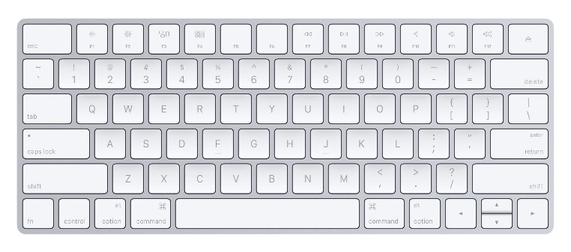

Fixture

#### Grade B

As well as fulfilling Pass-Level, the program needs to be able to detect the keyboard anywhere in the image at any rotation. The rotation also needs to be displayed on the image.

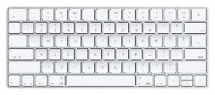

#### Grade A

As well as fulfilling Pass and grade B, the program needs to detect if there are any keys missing or misplaced on the keyboards. This needs to be indicated by some sort of graphical marker such as a ring or box with a text.

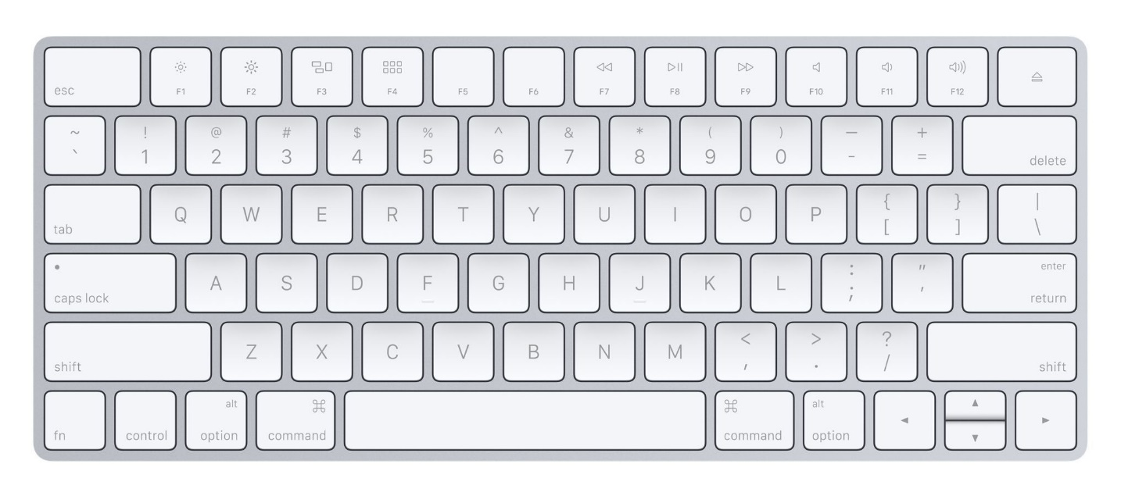

Key missing!